**MEB 3063 ENGINEERING TEAM PROJECT**

**EXTENDED PROPOSAL**

MAY 2020 SEMESTER

**“SMART DRUNK DETECTION”**

By Group 23

|  |  |  |
| --- | --- | --- |
| **NAME** | **PROGRAMME** | **ID** |
| TAN LI TUNG | EE | 17002803 |
| NAZRUL AIMAN MAT AKHER | ME | 17005555 |
| NUR FATHIAH ZOLKIFLI | CE | 17004851 |
| DANIAL HARIEZ AHMAD NIZAM | ME | 17004263 |
| WONG XIAN WAN | CE | 16003946 |

**SUPERVISOR:**

DR. NOORAINI BT ZAINUDDIN

ASSOC. PROF. DR. HANITA BT DAUD

***TABLE OF CONTENT***

**1.0 INTRODUCTION 3**

1.1 BACKGROUND 3

1.2 PROBLEM STATEMENT 5

1.3 OBJECTIVES 5

**2.0 DESIGN THINKING 6**

2.1 LITERATURE REVIEW 6

2.2 DESIGN THINKING TOOLS 8

**3.0 DESIGNING 11**

3.1 ALTERNATIVE DESIGN 11

3.2 FINALIZED DESIGN AND JUSTIFICATION 12

**4.0 PROJECT MANAGEMENT PLANNING 13**

4.1 TASKS LISTING AND DISTRIBUTION 13

4.2 GANTT CHART 14

4.3 PROJECT WORKFLOW 15

4.4 FEASIBILITY OF PLAN 16

**5.0 METHODOLOGY 17**

5.1 WORKFLOW OF PRODUCT 17

5.2 IDENTIFICATION OF TOOLS AND SOFTWARE 18

5.3 JUSTIFICATION OF FABRICATION CHOICES 21

**6.0 ECONOMICAL/ BUSINESS CONSIDERATION 22**

6.1 CAPITAL COST CONSIDERATIONS 22

6.2 OPERATIONAL COST CONSIDERATIONS 22

6.3 ALTERNATIVE MATERIAL 23

**7.0 CONCLUSION 24**

**8.0 REFERENCES 25**

***1.0 INTRODUCTION***

**1.1 BACKGROUND**

For the past several weeks, there is an increased rate of road accidents due to drunk driving. This problem once again has become a hot issue in Malaysia. Research provided by the Economic and Social Commission for Asia and the Pacific (ESCAP) of the United Nations (2019), drunk driving contributed for around 25% of deaths on Malaysian roads as of 2018 [8]. Around 2,281 individuals were affected by drink driving accidents in Malaysia from 2011 to 2018, with about half of them dying and about half of them either suffering serious or minor injuries. This is not a small amount of numbers that can be neglected. Drunk drivers are basically a threat on the road that jeopardize innocent’s and their life.

**Figure 1: Number of Persons Who Were Injured or Died from Drunk Driving Accidents in Malaysia**

Under the former Road Transport Act 1987 drunk driving is subject to Section 45A (1) which provides for a fine of not less than RM1,000 and not more than RM6,000 or imprisonment not less than 12 months. For drunk driving that lead to death, offenders are subject under Section 44 of the Road Transport Act 1987, which carries a maximum fine of RM10,000 and a maximum jail term of 12 months. Yet actually, based on the general opinion, these penalties are seen as ineffective to deter drunk driving.

According to Jenis (2020), Datuk Shahul Hamid Abd Rahim a criminology claimed that Malaysia’s government should act on reforming nation’s laws to provide stricter punishment for drunk drivers [4]. This is due to the ignorance of drunk driver to current law. However, it is not a convenience way because developing a new law it needs to undergo eight steps which are recommendation, formulation, first reading in Dewan Rakyat, second reading in Dewan Rakyat, discussion, third reading in Dewan Rakyat, debate in Dewan Negara and submission to Yang di-Pertuan Agong to be gazetted (Tham, 2018) [6]. This process might take a long time. Thus, a new solution that are more convenience, time saving and feasible must be used to comply on the third Sustainable Development Goal (SDG) which are to ensure healthy lives and promote well-being for all at all ages.

Understanding the severity of the situation, we from Engineering Team Project Group 23 came together to develop an idea which are a device that attached in a car that can sense alcohol content of the driver. The device called as Smart Drunk Detection targets the sub goals of SDG 3: Ensure healthy lives and promote well-being for all at all ages, specifically target 3.6: By 2020, halve the number of global deaths and injuries from road traffic accidents [10].

**1.2 PROBLEM STATEMENT**

There are lot of people dies from the road accident due to drunk driver. This behaviour not just threaten the driver itself but the others innocent life on the road. Current law seems inadequate or ineffective but to reform a new law, it takes a long time and by the mean time there are high possibilities that the rate of road accidents due to drunk driving keep on increasing. Also, the current way of detecting drunk drivers using breathalyser is not effective enough to stop the drunk drivers on the road. However, the accuracy of a breathalyser can be affected by a few factors, including error margin, partition ratios, radio frequency interference, improper calibration of device, left over alcohol in the drivers mouth and tainted breath samples (Attorney, J., 2020) [2]. A device with new drunk detection mechanism is needed in each of the vehicle.

**1.3 OBJECTIVES**

This project aims to achieve following objectives:

* Develop an easy-installed prototype named Smart Drunk Detector that can measure the alcohol concentration in the air inside the vehicle.
* Utilise the artificial intelligence (face recognition) technology in drunk detection mechanism.

***2.0 Design Thinking***

**2.1 LITERATURE REVIEW**

According to Drunk Driving Penalties in Malaysia (2019), drunk driving is one of the contributors of road trauma in Malaysia [3]. Drunk driving is considered a very serious offence. If a person is caught driving in a drunk condition, the person may face penalties ranging from the suspension, disqualification or cancellation of their licence, fines, or imprisonment. In Malaysia, the legal blood alcohol concentration (BAC) limit for drivers is below 0.08. The BAC can be measured by using a breathalyser. It is an offence if a person refuses to take the breathalyser test (Drunk Driving Penalties in Malaysia, 2019) [3]. Drunk drivers also can be detected through observing abnormal driving behaviours.

The first way to identify a drunk driver is through the use of breathalyser. However, the accuracy of a breathalyser can be affected by a few factors, including error margin, partition ratios, radio frequency interference, improper calibration of device, left over alcohol in the drivers mouth and tainted breath samples (Attorney, J., 2020) [2]. The measurements will also be affected by the physiological factors of the drivers, such as gender, weight, breathing pattern and body temperature. This makes the use of breathalyser inaccurate.

Secondly, the way that a police officer identifies a drunk driver is by observing the strange behaviours of a vehicle. The strange behaviours include accelerating or slowing down quickly, almost hitting an object or other vehicle**,** drifting (moving in a straight-line at a slight angle to the roadway), driving in the centre or on the wrong side of the road, erratic braking, looking drunk (face close to windshield, drinking in the vehicle, etc.) and slowly reacting to traffic signals (Protect Yourself from Drunk Drivers: What You can Do., 2020) [5].

When a drunk driver is spotted by another driver, the other driver would not try to stop or interfere with the vehicle, break any laws to keep the vehicle in view, follow the vehicle too closely (it may stop suddenly) or try to detain the driver if the vehicle stops. This situation occurs because people do not want to risk their life to stop the drunk driving. The only thing that can the driver do is to call the police officers (Protect Yourself from Drunk Drivers: What You can Do., 2020) [5].

From the above evidences, it is clearly shown that we need a drunk detection system that can instantly detect drunk drivers and stop them from being on the road. The use of breathalyser will not be sufficient in reduce the drunk drivers on the road.

**2.2 DESIGN THINKING TOOLS**

**a) Analogous Inspiration**

According to “Analogous Research” (2018) [2], analogous inspiration is defined as *“a way to look for solutions in different contexts that may be applicable to your challenge or inspire an idea that is.”* With a source of inspiration, analogous inspiration is able to trigger ideas in sectors different to the original inspiration.

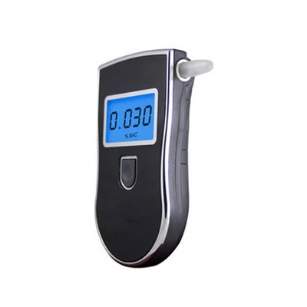Our team started with a brainstorming session. We have identified that the drunk driving is a very serious issue in Malaysia. We established a consensus that we want to focus on improving the current drunk detection system, which is by using a breathalyser by police. Our team started to figure out how to automate the breathalyser in a car by fixing the breathalyser inside the car. The driver would be required to use pass the breathalyser test before they can start the car engine.

**Figure 2: Breathalyser**

However, a drunk person might not know how to use a breathalyser due to the unconscious mind. This makes the use of breathalyser impractical. Our team utilise the analogous inspiration and we got a more advanced and suitable idea from the field of infrared and artificial intelligence (AI).

We have used the concept of analogous inspiration and we got the idea of utilising the use of AI to identify drunk driver. We also thought of using a nondispersive infrared (NDIR) sensor to detect the alcohol level of the air inside the car. This would further increase the accuracy of the detection system.

**b) Survey**

Our team members decided to publish a survey to gain more insights for your project and validate our problem statement. We have received a total of 92 responses from the survey. The results are as follows.

*1. Do you know what is drunk driving?*

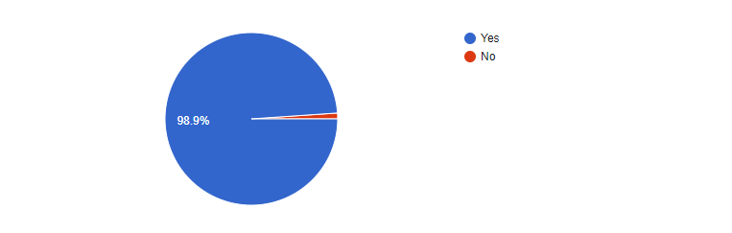

**Figure 3: Public Knowledge on Drunk Driving**

From the survey, 98.9% of the respondents know what drunk driving is. This helped us to validate our problem statement. The recent news displayed a lot of cases on drunk driving and this might be the reason for the public to know more about it.

*2. Have you encountered drunk drivers?*

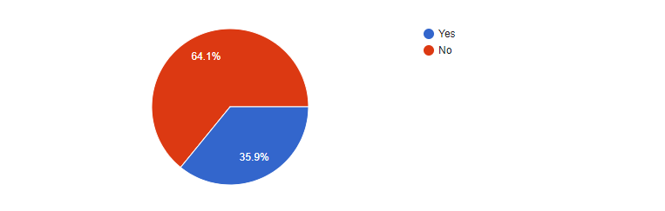

**Figure 4: Does the Public Encounter Drunk Drivers**

From these responses, we can see that 35.9% of the respondents personally encountered drunk drivers. This is a serious situation as drunk drivers can put the other drivers in danger. This is also an evidence that drunk driving needs to address.

*3. Do you think a smart drunk detection system can protect you from road accident?*

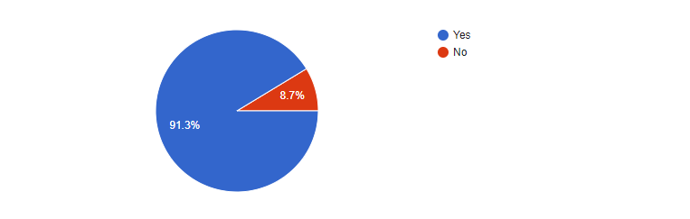

**Figure 5: Public Confidence on Smart Drunk Detection System**

From the survey, we can observe that 91.3% of the respondents are confident that Smart Drunk Detection system can protect them from road accident. This is a good sign for your team to develop the project as it will be helpful to the people especially drivers.

*4. What matters the most when it comes to a drunk detection system?*

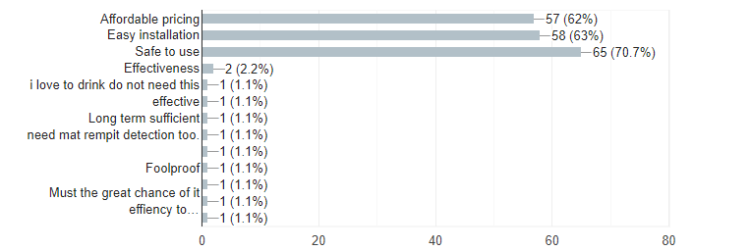

**Figure 6: Aspect That Matter the Most by The Public**

As expected, the public are most concern about the safety of the product. This is exactly the problem that we wanted to solve as the use of breathalyser is not effective enough at this point of time. The public also wish to have a device that can be easily installed and does not cost them a lot.

With this information, our team can build a drunk detection system that is affordable, reliable and safe to use. In short, we can conclude that our product will have a good market value as it can help to reduce the risk of drivers being expose to road accidents caused by drunk drivers.

***3.0 DESIGNING***

To fulfil its purpose, Smart Drunk Detection requires the following:

1. An Infrared Light sensor to detect the alcohol level
2. Internal circuitry to determine the alcohol level and to control the output

**3.1 ALTERNATIVE DESIGN**

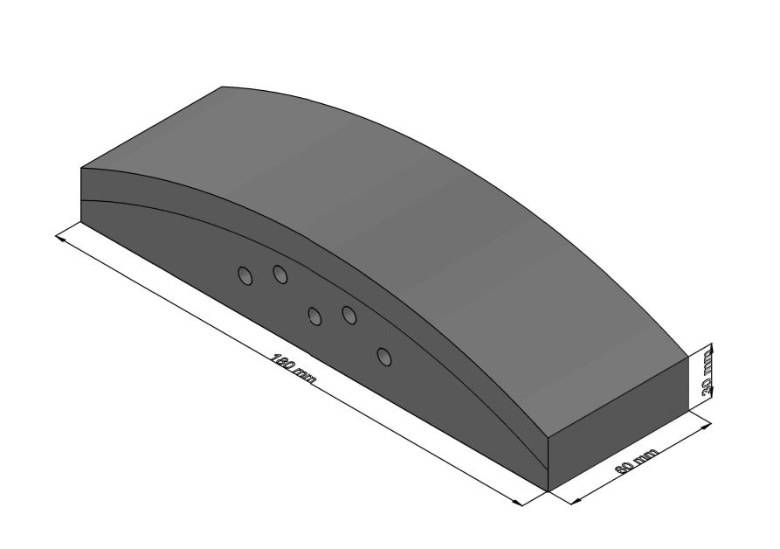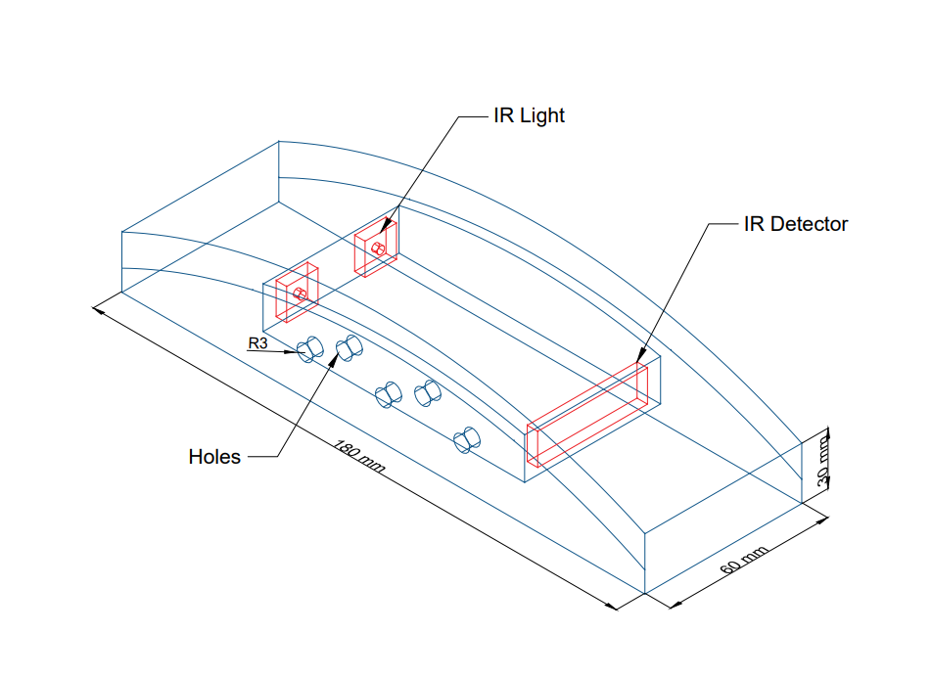

**Figure 7: First Alternative Design**

The first design is as shown in Figure 7. At the front side of the device, there are 5 holes that will act as an inlet and outlet for the air molecules to enter and exit the device. The two red boxes will be the source of the infrared light and the plate at the other end will act as the infrared light detector. This device is designed with a curved shaped at the top to blend well when it is put on a steering wheel.

After deeper analysis, we have decided that this design wont fully meet our needs such as the accuracy of just one drunk detection device. The box-shaped chamber is not very suitable for the existing NDIR sensor in the market. Therefore, this design needs some major adjustments to be made to fully optimize the needs of this device.

**3.2 FINALIZED DESIGN & JUSTIFICATION**

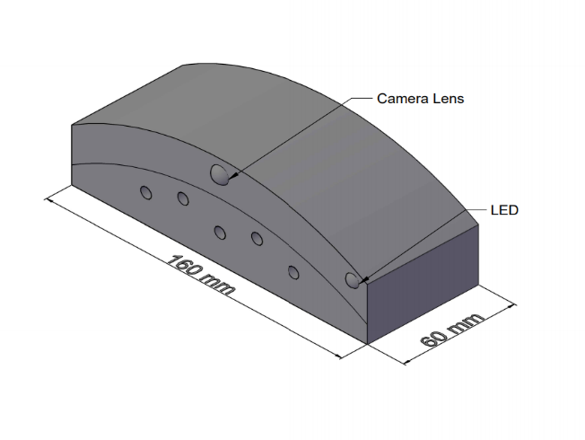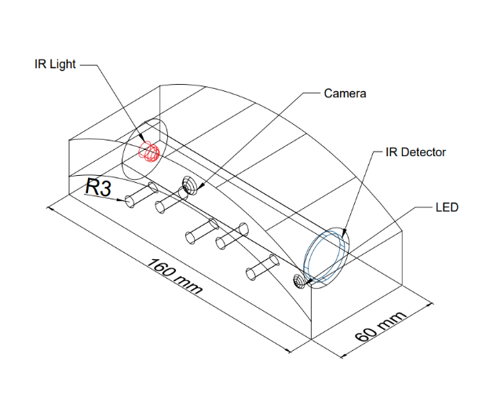

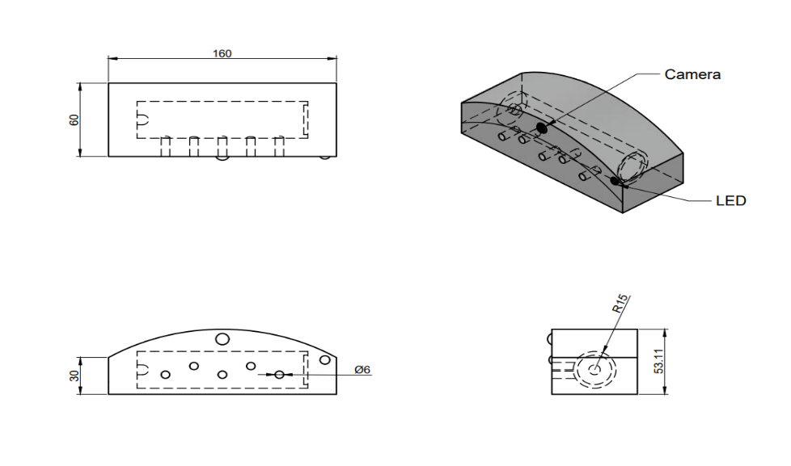

**Figure 8: Finalized Design**

The finalized design is as shown in Figure 8. The initial shape of this design is kept as it is to maintain its sleek shape to blend well with the steering wheel. The location and number of inlet and outlet holes are also kept as the initial design.

From the previous design, we have made a few changes. The first major change is the new additional feature to this device which is a camera. This camera works as a facial recognition camera to add another drunk detection device for additional accuracy. The second change made is the addition of LED light that will warn the driver if the IR sensor sense alcohol presence when the car is already driving on the road. The last change made is the shape of the chamber where the Infrared sensor and Infrared detector is located. We have decided with a cylindrical chamber as most NDIR sensors in the market are tube shaped.

***4.0 PROJECT MANAGEMENT PLANNING***

**4.1 TASK LISTING AND DISTRIBUTION**

|  |
| --- |
| Tan Li Tung (17002803) |
| * **Project Director** * Organize and coordinate team meetings * Supervise project progress according to Gantt chart * Lead the designing of electrical circuits * Identify items and prices of electrical components * Compile and proofread reports * Compile the programming work |

|  |
| --- |
| Nur Fathiah Zolkifli (17004851) |
| * **Secretary** * Conduct literature review * Ensure each member submit the reflection form * Take attendance at each meeting and keep track of all deadlines * Prepare relevant documentation (e.g. minutes of meeting) * Conduct survey and questionnaire |

|  |
| --- |
| Nazrul Aiman Mat Akher (17005555) |
| * **Technical Director** * Conduct research on analogous inspiration * Handle the exterior design of project * Researching items and prices for construction of prototype * Advise on choice of materials * Conduct research on tools and software used in designing |

|  |
| --- |
| Danial Hariez (17004263) |
| * **Creative Director** * Conduct research on similar products on market * Handle the interior design of project * 3D drawings with AutoCAD * Select and compare alternatives in materials * Conduct research on related articles to support fabrication process |

|  |
| --- |
| Wong Xian Wan (16003946) |
| * **Simulation Director** * Prepare Gantt chart * Conduct background research on problem statement and objectives * Conduct research regarding the current solution * Create methodology and workflow of the project * Conduct simulation for the project * Evaluate the functionality of the project |

**4.2 GANTT CHAT (ACTIVITIES AND MILESTONE)**

|  |  |  |  |  |  |  |  |  |  |  |  |  |
| --- | --- | --- | --- | --- | --- | --- | --- | --- | --- | --- | --- | --- |
| Task Details | 1/6 | 8/6 | 15/6 | 22/6 | 29/6 | 6/7 | 13/7 | 20/7 | 27/7 | 3/8 | 10/8 | 17/8 |
| 7/6 | 14/6 | 21/6 | 28/6 | 5/7 | 12/7 | 19/7 | 26/7 | 2/8 | 9/8 | 16/8 | 23/8 |
| W1 | W2 | W3 | W4 | W5 | W6 | W7 | W8 | W9 | W10 | W11 | W12 |
| ETP briefing |  |  |  |  |  |  |  |  |  |  |  |  |
| First supervisor consultation |  |  |  |  |  |  |  |  |  |  |  |  |
| Design thinking workshop |  |  |  |  |  |  |  |  |  |  |  |  |
| Meeting with supervisor |  |  |  |  |  |  |  |  |  |  |  |  |
| Individual reflection |  |  |  |  |  |  |  |  |  |  |  |  |
| Brainstorming (SWOT analysis) |  |  |  |  |  |  |  |  |  |  |  |  |
| Finalization of Project Idea |  |  |  |  |  |  |  |  |  |  |  |  |
| In-depth Project Research |  |  |  |  |  |  |  |  |  |  |  |  |
| Marketability review & research |  |  |  |  |  |  |  |  |  |  |  |  |
| Problem statement and solution |  |  |  |  |  |  |  |  |  |  |  |  |
| 3D modelling |  |  |  |  |  |  |  |  |  |  |  |  |
| Schematic design |  |  |  |  |  |  |  |  |  |  |  |  |
| Simulation of Model |  |  |  |  |  |  |  |  |  |  |  |  |
| Extended proposal first draft |  |  |  |  |  |  |  |  |  |  |  |  |
| Proposal draft review |  |  |  |  |  |  |  |  |  |  |  |  |
| Extended proposal final submission |  |  |  |  |  |  |  |  |  |  |  |  |
| Development of design concept |  |  |  |  |  |  |  |  |  |  |  |  |
| Design concept draft |  |  |  |  |  |  |  |  |  |  |  |  |
| Simulate design concept |  |  |  |  |  |  |  |  |  |  |  |  |
| E-poster presentation preparation |  |  |  |  |  |  |  |  |  |  |  |  |
| Video presentation preparation |  |  |  |  |  |  |  |  |  |  |  |  |
| Demonstration of design concept |  |  |  |  |  |  |  |  |  |  |  |  |
| Group & individual video presentation |  |  |  |  |  |  |  |  |  |  |  |  |
| Evaluation of design concept |  |  |  |  |  |  |  |  |  |  |  |  |
| E-Poster evaluation |  |  |  |  |  |  |  |  |  |  |  |  |
| Final Report Preparation |  |  |  |  |  |  |  |  |  |  |  |  |
| Submission of Final Report |  |  |  |  |  |  |  |  |  |  |  |  |
| Submission of Peer Evaluation Form |  |  |  |  |  |  |  |  |  |  |  |  |
| Individual contribution |  |  |  |  |  |  |  |  |  |  |  |  |

|  |  |  |  |
| --- | --- | --- | --- |
| Legend | Complete | Due | Overdue |

**4.3 PROJECT WORKFLOW**

Brainstorming for the ideas of this project

Simulation succeeds

Simulation failed

Ideas is not feasible, not viable or not align with the theme

Ideas is feasible, viable and align with the theme

Video presentation and final report

Final checking on simulation

Demonstration to supervisor and panel

Testing the simulation

Build the model in simulation tool

Prepare the proposal

List 4 ideas and choose the best idea after discussion with supervisor

**4.4 FEASIBILITY OF PLAN**

The finalized design has been done and presented to the supervisor. We are approved to proceed with the project. Large amount of research has been carried out to endure the product uses cost-effective materials so that it is affordable to everyone. There are plenty of online resources such as TinkerCAD, circuit.io and PowToon that can help us in the simulation and also preparation of design concept. These tools make the

Based in the Gantt chart, two weeks would be spent working on design concept and simulation as these steps take longer time. This will also provide rooms for the project improvement. One week after the design concept and simulation would be used to prepare the video presentation and E-poster presentation. There are lots of resources and tools online that can help us to complete the design concept and simulations. Therefore, we believe that the plan is feasible, and our team would be able to finish the project within the designated time frame.

***5.0 METHODOLOGY***

**5.1 WORKFLOW OF THE PRODUCT**

NDIR sensing and image recognizing

False

True

True

False

False

True

Buzzer starts to beep and LED starts to blink, driver must stop within 5 minutes

Take image of driver every 5 seconds

Image recognition output “normal”

Engine is on

Lock engine

NDIR value lower than threshold and image recognition output “normal”

Allow engine ignition

**5.2 IDENTIFICATION OF SUITABLE TOOLS AND SOFTWARE**

Based on the workflow above, we need a few components in this project:

1. Microcontroller
2. Camera
3. NDIR Sensor
4. LED
5. Buzzer

Our team has identified a few options for each of the component listed above.

|  |  |  |  |
| --- | --- | --- | --- |
| **No** | **Item** | **Selection** | **Purpose** |
| **1** | **Microcontroller**  Arduino Uno Rev3-Main Board  Raspberry Pi 3 Model B+ Arduino Uno | Raspberry Pi 3 Model B+ | Our project work with machine learning algorithm that runs on Python. Raspberry Pi is more compatible with Python compared with Arduino Uno. |
| **2** |  USB 12.0 MP 6 LED Webcam Camera Web Cam With Built in For Laptop ...Raspberry Pi 8MP Camera Module V2  Mini USB Camera Webcam Pi Camera | Mini USB Camera | The camera needs to be small in size to fit into the device. Therefore, the Webcam cannot be used. Mini USB Camera is chosen in our project because it is cheaper as compared to Pi Camera. Pi Camera can be used when the allocated budget is higher. |
| **3** | **NDIR Sensor** MH-Z14A Banggood T6703 MH-Z19 | MH-Z14A | NDIR MH-Z14A is widely used as compared to the other models. This model is also cheaper as compared to the others. |

The chosen tools and software used in this project are listed as below with its purpose:

|  |  |  |
| --- | --- | --- |
| **No** | **Item** | **Purpose** |
| **1** | **Raspberry Pi 3 Model B+**   | Microcontroller of the device. Raspberry Pi 3 Model B+ is chosen as the machine learning algorithm is more compatible with it. The Raspberry Pi 3 Model B+ can execute the tasks faster as compared to the other model. |
| **2** | **Mini USB Camera**   | To take image of the driver. This camera is chosen as it is small in size and affordable. |
| **3** | **NDIR Sensor**   | To detect the alcohol concentration in the air in the car. This sensor is more accurate as compared to the gas sensor module. |
| **4** |  | Blink to indicate that the driver needs to stop the car within 5 minutes. |
| **5** |  | To alert the sleepy driver by creating beeping sound. |

The software used in this project are as below:

|  |  |  |
| --- | --- | --- |
| No | Software | Function |
| 1 | AutoCAD | To model the prototype in 3D |
| 2 | Online schematic tools | Design circuit schematics |

**5.3 JUSTIFICATION OF FABRICATION CHOICES**

For the prototype, plastic is chosen for the overall material. Plastics are derived from organic, natural materials such as coal, salt, natural gas, cellulose and also crude oil. As plastics are known to be good insulators, it is the most reasonable choice of material to be chosen for our prototype. As our prototype is built around a number of electrical components such as NDIR sensor and camera, material with good electrical insulator is best used to avoid current leakage throughout the whole prototype to prevent further problems such as current leakage and short circuit. Plastics are also widely produced making our prototype very cost effective considering the cheap price of plastics today. Aside from that, the material chosen has to be very light as our prototype needs to be attached to the steering wheel. An abundance of weight means that the steering wheel will be heavier causing discomfort to the driver. Plastic is a perfect material for this as it is very light (“The Properties of Plastic”, 2018) [7].

***6.0 ECONOMICAL/ BUSINESS CONSIDERATION***

**6.1 CAPITAL COST CONSIDERATION**

This capital cost needed for the project are as below. The cost listed is the estimated cost as the project is conducted fully online.

|  |  |  |  |
| --- | --- | --- | --- |
| **Item** | **Unit Price (RM)** | **Quantity** | **Subtotal (RM)** |
| Raspberry Pi 3 Model B+ | 120.00 | 1 | 120.00 |
| Buzzer | 1.00 | 1 | 1.00 |
| LED | 0.10 | 1 | 0.10 |
| Resistor | 0.05 | 1 | 0.05 |
| Jumper Wire | 2.50 | 1 | 2.50 |
| NDIR Sensor | 90.00 | 1 | 90.00 |
| Mini USB Camera | 40.00 | 1 | 12.00 |
| Battery Holder | 5.20 | 1 | 5.20 |
| Plastics sheet | 10.00 | 1 | 10.00 |
| **Total (RM)** | | | **240.85** |

**6.2 OPERATIONAL COST CONSIDERATION**

Since the project is carried out online, there is no cost involved in the fabrication process. In UTP, students are able to fabricate the product at the Engineering, Prototyping and Innovation Center. Once the product is commercialised, the fabrication process would be carried out in a factory which can reduce the cost as the production are usually in bulk. The Smart Drunk Detection System is advisable to run using the power supply outlet in the car itself.

**6.3 ALTERNATIVE MATERIALS**

Plexiglass can be used to replace plastic as an alternative material. Plexiglass is a transparent petroleum-based material often manufactured in sheets as lightweight and shatter-resistant alternative to glass (“What is Plexiglass”, 2019) [9]. The most important characteristics of plexiglass is that it is an electrical insulator which can prevent current leakage in the system of the prototype. Plexiglass is an easy material to fabricate, bonds well with adhesive and solvents which means it will not cost much to create the prototype. The lightweight that this material offer is excellent for the prototype. It also has superior weathering properties compared to other types of plastics which means it will last a long time.



**Figure 9: Plexiglass**

As for the camera, it is possible to increase the accuracy of the drunk detection by having a camera with a better resolution. In the case of this project, a Pi Camera can be used as an alternative for the Mini USB Camera. Pi Camera is chosen as alternative as it has a higher resolution and it is compatible with Raspberry Pi.

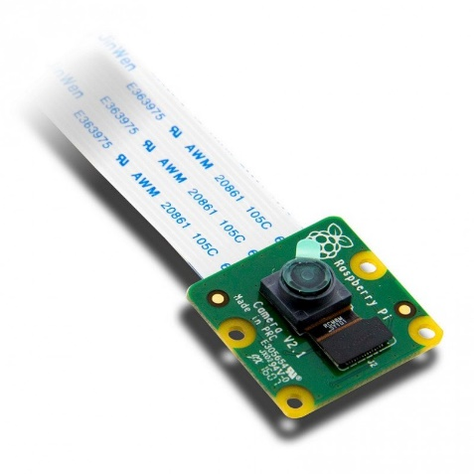

**Figure 10: Pi Camera**

***7.0 CONCLUSION***

Drunk driving is a threaten to the safety of people on the road especially in Malaysia. This issue needs immediate attention and action to resolve it. There are lot of possible solution that can be implemented such as from the perspective of law, automotive and even technologies. The feasible solution for now is based on technologies perspective compared to the others.

After thorough research and studies, our group has come out with a device that combine sciences and technology to be the possible solution of this problem. Smart Drunk Detection is a device that come up with nondispersive infrared (NDIR) sensor that can detect the alcohol content of the driver along the period time of driving. The project will also utilise the technology of artificial intelligence (AI), specifically machine learning (ML) algorithm to enhance the accuracy of the detection. This is very useful because it keeps on observe the driver and can also alert the driver. Our product has great features and system that can be on the market of automotive industry in order to cope with the drunk driving issue.

For the next action, we will do the animation on how Smart Drunk Detection will works in certain circumstances to give better view or idea on our product. It is a simple animation yet informative and neat so it can be delivered well. Our team will also start to work on the simulation of the model to support the feasibility of the project.

In conclusion, this project is capable of avoid as many as possible drunk driver on the road by locking the car engine and alert the sleepy drivers. Thus, it can help in reducing the road fatalities due to the drunk driving. We hope this product will be implemented in cars to add safety features in it.

**8.0 REFERENCES**

[1] Analogous Research | Design Methods for Education Policy. (2019). Retrieved 23 June 2020, from https://designforedpolicy.org/analogous-research

[2] Attorney, J. (2020). How Accurate Are “Breathalyzers”?. Retrieved 6 July 2020, from https://www.lawyers.com/legal-info/criminal/dui-dwi/how-accurate-are-breathalyzers.html

[3] Drunk Driving Penalties in Malaysia. (2019, August 22). Retrieved June 24, 2020, from https://andatech.com.my/drink-driving-penalties-in-malaysia/

[4] Jenis, A. (2020, May 28). Calls for stricter punishment against drunk drivers. Borneo Post Online. Retrieved from https://www.theborneopost.com/2020/05/28/calls-for-stricter-punishment-against-drunk-drivers/

[5] Protect Yourself from Drunk Drivers: What You can Do. (2020). Retrieved 7 July 2020, from https://www.alcoholproblemsandsolutions.org/protect-yourself-from-drunk-drivers/

[6] Tham, J, V. (2018, Apr 8). 8 Stages A Bill Goes Through Before Being Passed As Law In Malaysia. SAYS. Retrieved from https://says.com/my/news/stages-a-bill-goes-through-before-being-passed-as-law-in-malaysia

[7] The Properties of Plastic. (2018, March 19). Retrieved from https://www.osborneindustries.com/news/plastic-properties/

[8] United Nations, Economic and Social Commission for Asia and the Pacific (ESCAP) (2019). Strategies to Tackle the Issue of Impaired Driving for Road Safety in the Asia-Pacific Region: Implementation Framework. Retrieved 27 June 2020, from https://www.unescap.org

[9] What Is Plexiglass and What Is It Made Of?. (2019, May 5). Retrieved 21 June 2020, from https://glassdoctor.com/blog/what-is-plexiglass-and-what-is-it-made-of